**Chloroplast Sugar Phosphate Metabolism**

My primary research interest is on hexose phosphate metabolism in the chloroplast stroma. This interest has evolved through my career and began as a more broad interest is photosynthesis. Photosynthesis can be limited by starch and sucrose synthesis (Sharkey et al., 1994) which led me to seek a deeper understanding of starch and sucrose metabolism. My studies of starch metabolism led to a fundamental change in the understanding of starch degradation in the chloroplast at night. We now know that starch is broken down to maltose and that this maltose is used in the cytosol in combination with a cytosolic heteroglycan to make sucrose (Lu and Sharkey, 2004; Weise et al., 2004). The knowledge gained from this work was utilized to generate transgenic Arabidopsis and corn with increased leaf starch that could be beneficial to biofuel or agricultural industries (Weise et al., 2012). This work has led to many questions about the role of sugar phosphate metabolism in both starch degradation and photosynthetic metabolism.

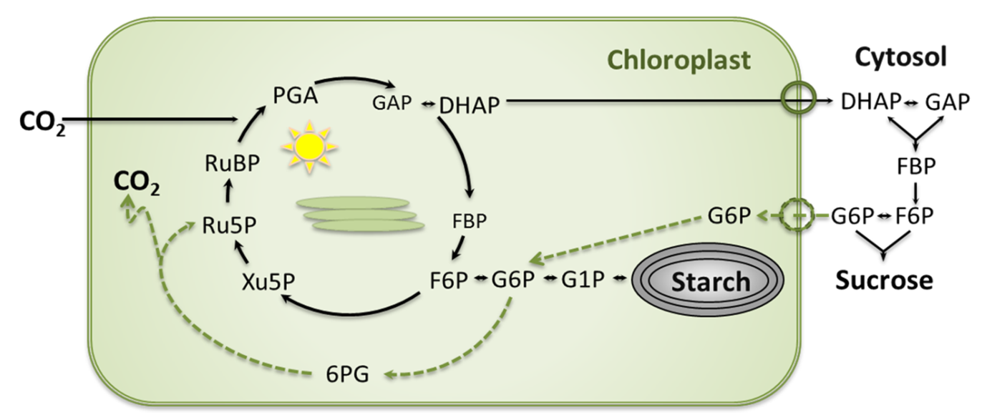

Calvin-Benson cycle, sucrose, and starch synthesis pathways with the chloroplast G6P transporter (GPT2) expressed. GPT2 expression could lead to increased carbon flux through the G6P shunt.

We hypothesize that an alternative pathway (the G6P shunt) related to the Calvin-Benson cycle is important for regulating and stabilizing photosynthetic carbon metabolism and electron transport (Sharkey and Weise, 2017). Normally G6P concentration in the stroma is low. One reason it might be advantageous to keep the concentration of G6P low is to restrict G6P dehydrogenase (G6PDH) activity in the stroma. G6PDH activity is redox regulated and thought to be inactivated or low in the light. We are proposing that G6PDH is not completely inactivated in the light and that the oxidative branch of the pentose phosphate pathway may occur simultaneously with the Calvin-Benson cycle. I am currently working on projects to better understand the role of hexose phosphate metabolism and free phosphate metabolism in carbon capture and starch and sucrose metabolism.

In addition to research I teach ISB 204 which is an introductory biology class for non-science majors. I also help teach PLB 416 plant physiology lab and have guest lectured in PLB 415 plant physiology lecture. I also serve as the Michigan State Plant Biology Club faculty advisor and conduct various plant related science outreach activities such as MSU’s Science Festival, Fascination of Plants Day, and Science Nights at local elementary schools.

Sharkey, T.D., Socias, F.X. and Loreto, F. (1994) CO2 effects on photosynthetic end product synthesis and feedback In: *Gaseous Pollutants and Plant Metabolism* (Alscher, R.G. and Wellburn, A.R. eds), pp. 55-78. Elsivier.

Weise, S.E., Aung, K., Jarou, Z.J., Mehrshahi, P., Li, Z., Hardy, A.C., Carr, D.J. and Sharkey, T.D. (2012) Engineering starch accumulation by manipulation of phosphate metabolism of starch. *Plant Biotechnol J* **10**, 545-554.

Weise, S.E., Weber, A. and Sharkey, T.D. (2004) Maltose is the major form of carbon exported from the chloroplast at night. *Planta* **218**, 474-482.

Sharkey, T.D., and Weise, S.E. (2017) The glucose 6-phosphate shunt around the Calvin-Benson cycle. *JXB* **68**, 4731